**SMART TRAFFIC MANAGEMENT SYSTEM**

Soubhagya Ranjan Behera

**1.Abstract**

**Problem Statement**

Traffic congestion is a significant issue in urban areas, leading to increased travel time, fuel consumption, and environmental pollution. Traditional traffic management systems often rely on static traffic signals and manual control, which are insufficient to handle the dynamic nature of urban traffic. The need for an intelligent, adaptive traffic management system that can optimize traffic flow in real-time is imperative.

**Market/Customer/Business Need Assessment**

1. **Market Need**:
   * Urbanization: Rapid urbanization has led to increased vehicle ownership, exacerbating traffic congestion.
   * Smart City Initiatives: Governments worldwide are investing in smart city projects, which include intelligent transportation systems.
   * Environmental Concerns: Reducing traffic congestion contributes to lower emissions and improved air quality, aligning with global sustainability goals.
2. **Customer Need**:
   * Commuters: Reduced travel time and improved journey reliability.
   * Municipalities: Efficient use of infrastructure, reduced congestion, and enhanced public safety.
   * Businesses: Improved logistics and delivery times, leading to cost savings and better customer satisfaction.
3. **Business Need**:
   * Efficiency: Optimized traffic management can lead to cost savings for city administrations.
   * Public Safety: Better traffic flow reduces the likelihood of accidents and improves emergency response times.
   * Economic Growth: Improved traffic conditions can boost local economies by making cities more attractive to businesses and tourists.

**2.Target Specifications and Characterization**

1. **Traffic Flow Optimization**:
   * Real-time data collection from various sources (e.g., cameras, sensors, GPS).
   * Adaptive signal control based on real-time traffic conditions.
   * Integration with existing traffic management infrastructure.
2. **Data Analysis and Prediction**:
   * Advanced algorithms for traffic pattern analysis and prediction.
   * Machine learning models to adapt to changing traffic conditions.
   * Visualization tools for traffic management authorities to monitor and control traffic.
3. **User Interface**:
   * Mobile application for commuters to receive real-time traffic updates and alternative route suggestions.
   * Dashboard for traffic management authorities with real-time data visualization and control capabilities.
4. **Environmental Impact**:
   * Reduction in vehicle emissions through optimized traffic flow.
   * Integration with eco-friendly transportation solutions (e.g., public transport, electric vehicles).
5. **Scalability and Flexibility**:
   * Modular design to allow for easy upgrades and integration with new technologies.
   * Scalability to accommodate growing urban areas and increasing vehicle numbers.

**3.External Search**

( Information and Data Analysis ) These are some of the sources I visited for more information and need for shopping pattern analysis of customers.

The below data set are used

[Data Set](https://drive.google.com/file/d/1lwWVwOOci-65RQR73Nft4R3pWDC57P5s/view?usp=drive_link)

The above data set contains datetime , season , holiday , working day , weather ,temp ,

humidity, windspeed , casual , registered & count columns.

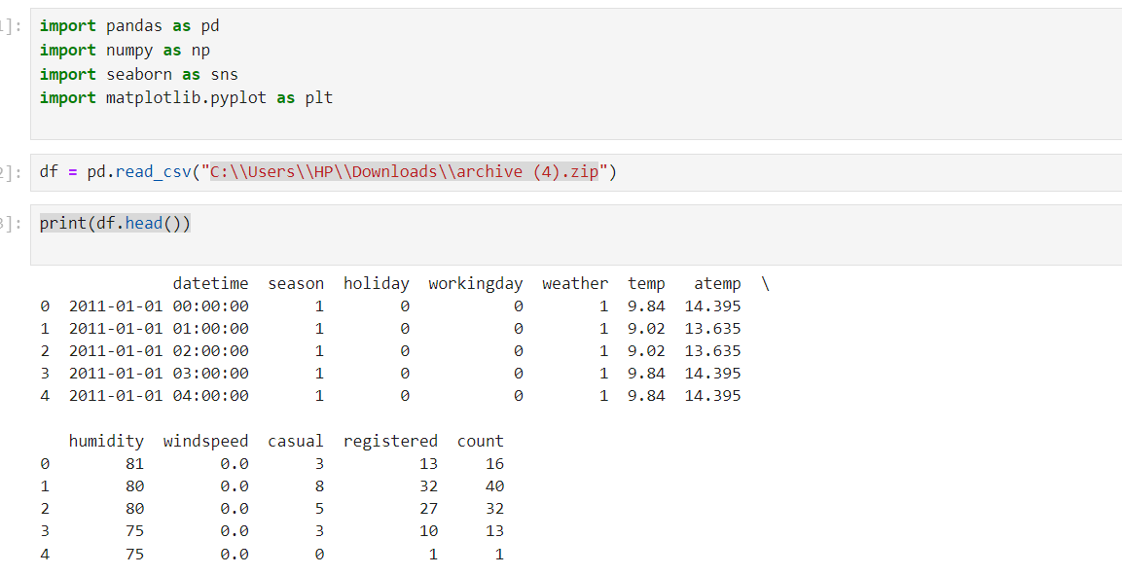

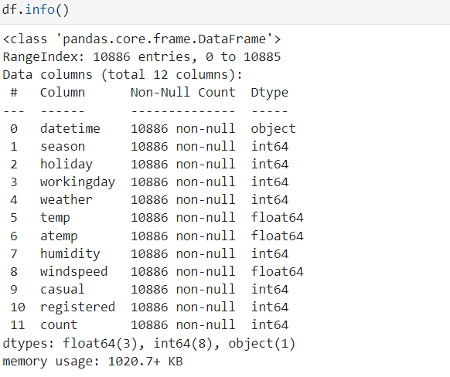

The above data set described as follows

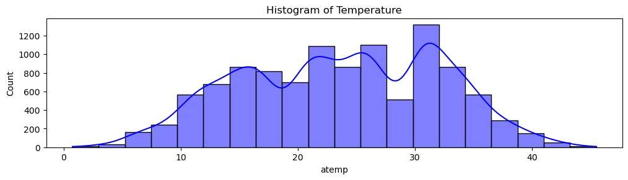

Temperature Histogram: Shows the distribution of temperature values recorded.

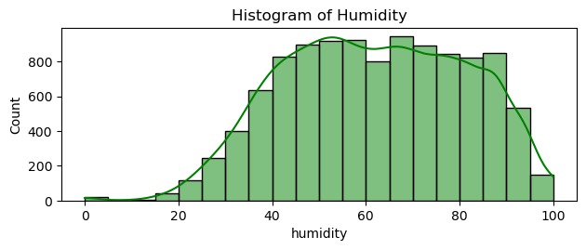

Humidity Histogram: Displays the distribution of humidity levels.

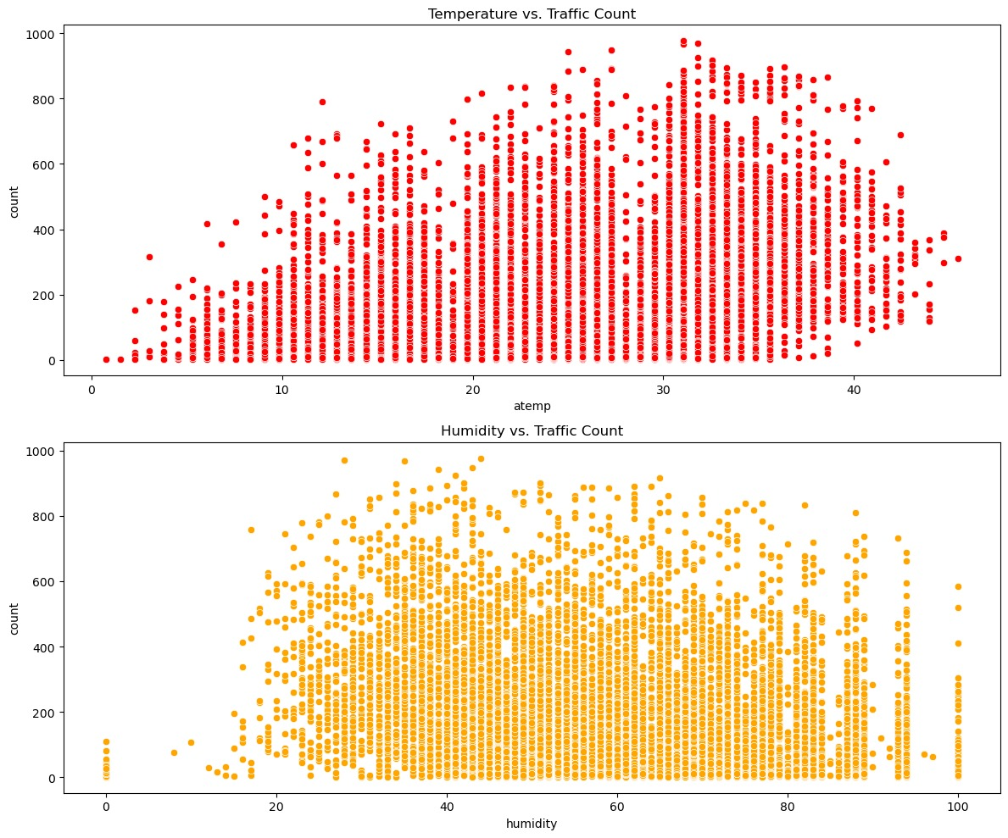

Temperature vs. Traffic Count Scatter Plot Indicates if there's any relationship between temperature and traffic volume.

Humidity vs. Traffic Count Scatter Plot Examines if humidity levels correlate with traffic volume.

The scatter plot shows a relationship between temperature and traffic count. There seems to be an upward trend initially, indicating that as the temperature increases, the traffic count also increases up to a certain point. After reaching a peak, the traffic count appears to decrease or stabilize with further increases in temperature.

The scatter plot shows a relationship between humidity and traffic count. There is a more dispersed distribution compared to the temperature plot, but it appears that the traffic count is higher at moderate humidity levels. At very low or very high humidity levels, the traffic count seems to be lower.

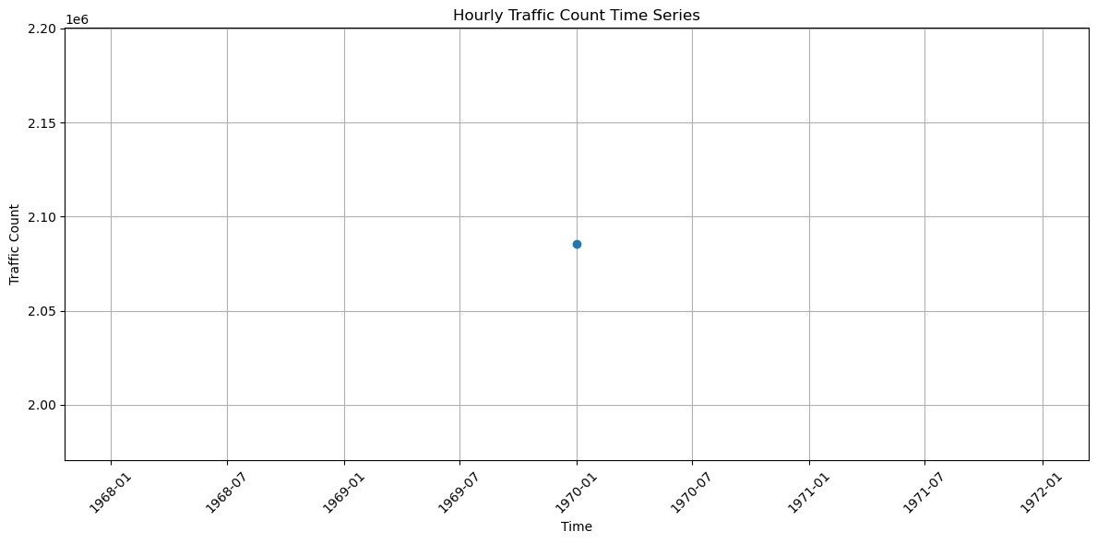

Hourly Traffic Count Time Series Illustrates how traffic volume fluctuates over hours, highlighting peak times.

Humidity vs. Traffic Count High humidity levels could impact traffic patterns, influencing congestion and travel times.

Hourly Traffic Count: Identifies peak hours when traffic volume is highest, suggesting times when traffic management strategies could be most effective.

These visualizations provide initial insights into how weather conditions and time influence traffic patterns, which are crucial for developing effective traffic management solutions.

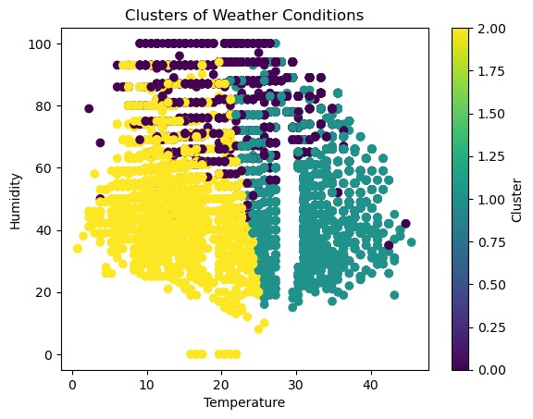

* The plot displays clusters of weather conditions based on temperature and humidity.
* Each data point is color-coded according to the cluster it belongs to.
* There are three distinct clusters shown, as indicated by the three different colors in the color legend.

**Clusters**:

1. **Cluster 0 (Yellow)**:
   * Predominantly found at lower temperatures (0 to 20 degrees) and a wide range of humidity levels (0 to 100%).
2. **Cluster 1 (Purple)**:
   * Found at moderate temperatures (10 to 30 degrees) and higher humidity levels (above 40%).
3. **Cluster 2 (Teal)**:
   * Predominantly at higher temperatures (20 to 45 degrees) and moderate to high humidity levels (20% to 80%).

The clustering likely helps in identifying patterns or similarities in weather conditions, which can be useful for further analysis or decision-making based on weather data

**Linear Growth Model**

For linear growth in a smart traffic management system, where total profit (y) is influenced by the pricing of the service (m), total sales (market as a function of time, x(t), and fixed costs (c), the equation is:

y=mx(t)+c

* y: Total profit
* mmm: Pricing of the service
* x(t): Total sales (traffic management usage as a function of time)
* c: Fixed costs (production, maintenance, etc.)

### Example:

Assuming:

* m=$10 per unit of service (e.g., per vehicle monitored)
* x(t) is the number of vehicles monitored over time, say x(t)=1000+50t (assuming 50 more vehicles are added each month)
* c=$5000 fixed costs per month

The total profit equation would be:

y=10⋅(1000+50t)+5000

y = 10000 + 500t + 5000

y=15000+500t

These equations provide frameworks to understand and predict financial outcomes based on different growth trends in a smart traffic management system.

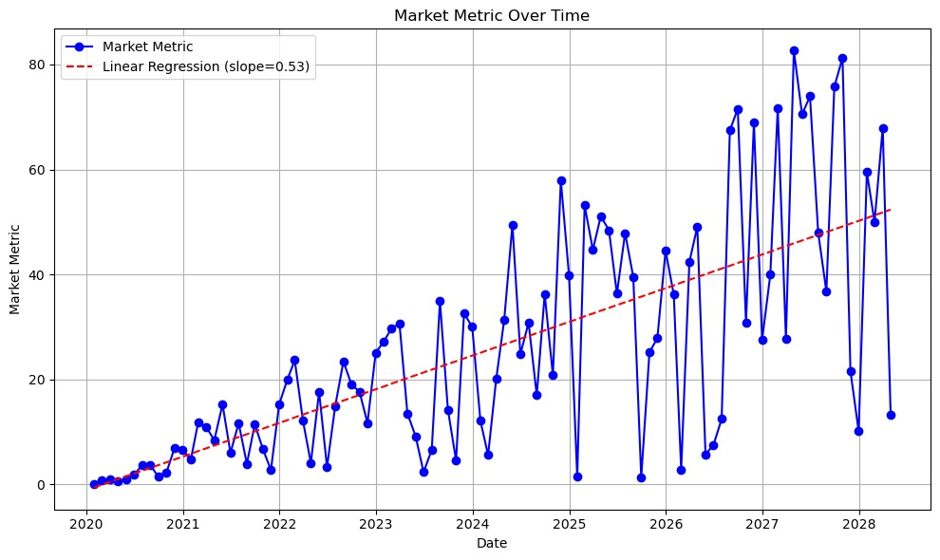

### **Conclusion**

In the analysis of financial models for a smart traffic management system using the linear growth scenario, we observed the following:

1. **Linear Growth Model**:
   * **Steady Increase**: The model shows a steady and predictable increase in total profit over time. This reflects a stable and incremental growth pattern in the usage of the traffic management system.
   * **Predictability**: Due to its straightforward nature, the linear growth model allows for easier forecasting and planning. Businesses can make informed decisions with a higher degree of confidence in expected outcomes.
   * **Suitability**: This model is particularly suitable for markets that are mature or have a stable growth rate. It assumes that the number of vehicles monitored will increase at a constant rate, making it ideal for regions where the adoption of smart traffic solutions is gradual and steady.

### **Insights:**

* The linear growth model is beneficial for planning and resource allocation in stable markets. It ensures a clear understanding of how total profit will grow over time, allowing for efficient budgeting and operational strategies.
* It is less complex and more manageable compared to models that assume rapid or fluctuating growth, making it suitable for long-term projects with incremental progress.

### **Applications:**

* **Smart Traffic Management Systems**: This model is ideal for implementation in regions where the market is already established, and the adoption of smart traffic solutions is growing at a consistent, manageable pace. It supports strategic planning and ensures that the financial outcomes are aligned with the gradual increase in service usage.

Understanding the linear growth model helps stakeholders maintain a steady course of action, ensuring sustainable growth and maximizing profits in stable market conditions.